English 10R Mrs. Murphy
Monday | Tuesday | Wednesday | Thursday | Friday
Sept 9  introduction  p.2 packet  read p. 3 packet | 10  discuss p. 3  read pp. 4-5 in packet | 11  discuss p. 4-5  HW: read Preface  pp. vii-xv in book | 12  discuss Preface  pp. vii-xv  in class complete worksheet p. 6 | 13  camps p. 7 packet  begin You Tube video  A Day In Auschwitz  (48 minutes)
16  finish You Tube video  A Day In Auschwitz  complete worksheet  p. 8 | 17  poems p. 10-11  “First They Came”  “Transit”  “Sandy Hook”  “Recipe” | 18  Night quiz on  Chapter 1  pp. 3-22  vocabulary p. 12-13 | 19  quiz on  Chapters 2 & 3  pp. 23-46  genocide p. 9 packet | 20  quiz on  Chapter 4  pp. 47-65
23  quiz on  Chapter 5  pp. 66-84  watch  Wiesel and Oprah | 24  quiz on  Chapters 6 & 7  pp. 85-103 | 25  quiz on  Chapters 8 & 9  pp. 104-115 | 26  discuss Nobel Peace Prize speech  pp. 117-120  worksheet p. 14 | 27  quick write p. 15

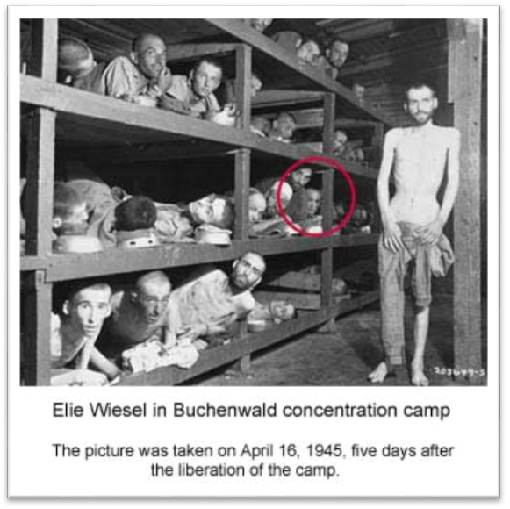
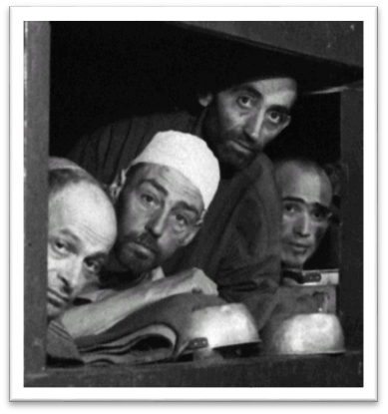

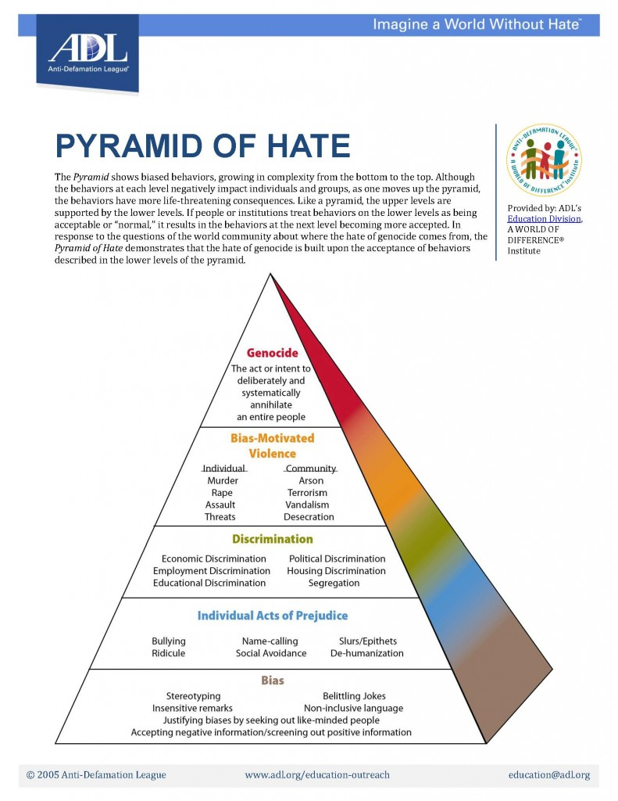

MS St. Louis German ocean liner https://www.britannica.com
The St. Louis was a transatlantic luxury liner owned by the Hamburg-American Line. On May 13, 1939, it departed from Hamburg, Germany, for Havana, Cuba, a popular stopover for refugees seeking to emigrate to the United States. On board were 937 passengers and 231 crew members; the captain was Gustav Schröder. Most of the travelers were Jews leaving Germany amid growing concerns over safety; some six months earlier Nazis had attacked Jewish persons and property in an event known as Kristallnacht. The passengers had obtained landing certificates to enter Cuba, where most would then wait for their U.S. visas to be approved.
However, before the ship departed, there were indications that the passengers would not be welcomed. In early May, Cuban Pres. Federico Laredo Brú signed a decree that invalidated the passengers’ landing certificates. His decision was supported by many Cubans who feared that the immigrants would compete for jobs as the country continued to struggle through the Great Depression. Further inflaming public opinion were rumors - which some believe were spread by Nazi agents on the island - that the Jewish passengers were communists and criminals. On May 8, a large anti-Semitic rally was held in Havana.
Against this backdrop, the St. Louis arrived on May 27, 1939. The Cuban government admitted 28 passengers who had the necessary paperwork but refused to let the other 908 travelers disembark; one of the elderly passengers had died during the voyage and was buried at sea. For the next several days, the American Jewish Joint Distribution Committee (JDC) attempted to negotiate with Cuban authorities. During this time, morale among the passengers waned, and one man attempted suicide by slashing his wrists and jumping overboard; he was taken to a hospital and allowed to remain in Cuba. As the talks dragged on - with money reportedly being at issue -Laredo Brú ordered the St. Louis to leave Cuban waters on June 2.
After waiting off the coast of Cuba for several days, Schröder sailed for Florida. However, the U.S. government also refused to admit the refugees, citing the country’s yearly immigration quota. The U.S. State Department told the refugees that they must “await their turns on the waiting list” - which was several years long. The U.S. Coast Guard shadowed the vessel, though the USCG later claimed its “units were dispatched out of concern for those on board” and not to keep the ship from docking. The Canadian government also refused to admit the refugees. As the saga continued, the Nazi regime used it as propaganda to support its anti-Jewish policies.
On June 6, 1939, Laredo Brú ended the negotiations. With supplies dwindling, the St. Louis began the voyage back to Europe later that day, and it reached Antwerp on June 17. Through talks spearheaded by the JDC, England, France, the Netherlands, and Belgium agreed to take the refugees, and by June 20 all the passengers had disembarked the St. Louis. In September World War II officially started. It was later determined that of the 907 passengers who returned to Europe, 255 were killed during the war; the vast majority of them died in concentration camps.
The incident was notably chronicled in the book Voyage of the Damned (1974) by Gordon Thomas and Max Morgan Witts. It was later adapted (1976) into a film. In 2017 the ill-fated voyage received new attention through a Twitter account - St. Louis Manifest - that listed the passengers who died during the war. The account was created the day before U.S. Pres. Donald Trump signed an executive order that suspended immigration from certain Muslim countries.

Excerpt: 'Less Than Human' by David Livingstone Smith
Before I get to work explaining how dehumanization works, I want to make a preliminary case for its importance. So, to get the ball rolling, I'll briefly discuss the role that dehumanization played in what is rightfully considered the single most destructive event in human history: the Second World War. More than seventy million people died in the war, most of them civilians. Millions died in combat. Many were burned alive by incendiary bombs and, in the end, nuclear weapons. Millions more were victims of systematic genocide. Dehumanization made much of this carnage possible.
Let's begin at the end. The 1946 Nuremberg doctors' trial was the first of twelve military tribunals held in Germany after the defeat of Germany and Japan. Twenty doctors and three administrators — twenty-two men and a single woman — stood accused of war crimes and crimes against humanity. They had participated in Hitler's euthanasia program, in which around 200,000 mentally and physically handicapped people deemed unfit to live were gassed to death, and they performed fiendish medical experiments on thousands of Jewish, Russian, Roma and Polish prisoners.
Principal prosecutor Telford Taylor began his opening statement with these somber words:
The defendants in this case are charged with murders, tortures and other atrocities committed in the name of medical science. The victims of these crimes are numbered in the hundreds of thousands. A handful only are still alive; a few of the survivors will appear in this courtroom. But most of these miserable victims were slaughtered outright or died in the course of the tortures to which they were subjected ... To their murderers, these wretched people were not individuals at all. They came in wholesale lots and were treated worse than animals.
He went on to describe the experiments in detail. Some of these human guinea pigs were deprived of oxygen to simulate high altitude parachute jumps. Others were frozen, infested with malaria, or exposed to mustard gas. Doctors made incisions in their flesh to simulate wounds, inserted pieces of broken glass or wood shavings into them, and then, tying off the blood vessels, introduced bacteria to induce gangrene. Taylor described how men and women were made to drink seawater, were infected with typhus and other deadly diseases, were poisoned and burned with phosphorus, and how medical personnel conscientiously recorded their agonized screams and violent convulsions.
The descriptions in Taylor's narrative are so horrifying that it's easy to overlook what might seem like an insignificant rhetorical flourish: his comment that "these wretched people were ... treated worse than animals". But this comment raises a question of deep and fundamental importance. What is it that enables one group of human beings to treat another group as though they were subhuman creatures?
A rough answer isn't hard to come by. Thinking sets the agenda for action, and thinking of humans as less than human paves the way for atrocity. The Nazis were explicit about the status of their victims. They were Untermenschen — subhumans — and as such were excluded from the system of moral rights and obligations that bind humankind together. It's wrong to kill a person, but permissible to exterminate a rat. To the Nazis, all the Jews, Gypsies and others were rats: dangerous, disease-carrying rats.
Jews were the main victims of this genocidal project. From the beginning, Hitler and his followers were convinced that the Jewish people posed a deadly threat to all that was noble in humanity. In the apocalyptic Nazi vision, these putative enemies of civilization were represented as parasitic organisms — as leeches, lice, bacteria, or vectors of contagion. "Today," Hitler proclaimed in 1943, "international Jewry is the ferment of decomposition of peoples and states, just as it was in antiquity. It will remain that way as long as peoples do not find the strength to get rid of the virus." Both the death camps (the gas chambers of which were modeled on delousing chambers) and the Einsatzgruppen (paramilitary death squads that roamed across Eastern Europe followed in the wake of the advancing German army) were responses to what the Nazis perceived to be a lethal pestilence.
Sometimes the Nazis thought of their enemies as vicious, bloodthirsty predators rather than parasites. When partisans in occupied regions of the Soviet Union began to wage a guerilla war against German forces, Walter von Reichenau, the commander-in-chief of the German army, issued an order to inflict a "severe but just retribution upon the Jewish subhuman elements" (the Nazis considered all of their enemies as part of "international Jewry", and were convinced that Jews controlled the national governments of Russia, the United Kingdom, and the United States). Military historian Mary R. Habeck confirms that, "soldiers and officers thought of the Russians and Jews as 'animals' ... that had to perish. Dehumanizing the enemy allowed German soldiers and officers to agree with the Nazis' new vision of warfare, and to fight without granting the Soviets any mercy or quarter."
The Holocaust is the most thoroughly documented example of the ravages of dehumanization. Its hideousness strains the limits of imagination. And yet, focusing on it can be strangely comforting. It's all too easy to imagine that the Third Reich was a bizarre aberration, a kind of mass insanity instigated by a small group of deranged ideologues who conspired to seize political power and bend a nation to their will. Alternatively, it's tempting to imagine that the Germans were (or are) a uniquely cruel and bloodthirsty people. But these diagnoses are dangerously wrong. What's most disturbing about the Nazi phenomenon is not that the Nazis were madmen or monsters. It's that they were ordinary human beings.
When we think of dehumanization during World War II our minds turn to the Holocaust, but it wasn't only the Germans who dehumanized their enemies. While the architects of the Final Solution were busy implementing their lethal program of racial hygiene, the Russian-Jewish poet and novelist Ilya Ehrenburg was churning out propaganda for distribution to Stalin's Red Army. These pamphlets seethed with dehumanizing rhetoric: they spoke of "the smell of Germany's animal breath," and described Germans as "two-legged animals who have mastered the technique of war" — "ersatz men" who ought to be annihilated. "The Germans are not human beings," Ehrenburg wrote, "... If you kill one German, kill another — there is nothing more amusing for us than a heap of German corpses."
This wasn't idle talk. The Wehrmacht had taken the lives of 23 million Soviet citizens, roughly half of them civilians. When the tide of the war finally turned, a torrent of Russian forces poured into Germany from the east, and their inexorable advance became an orgy of rape and murder. "They were certainly egged on by Ehrenburg and other Soviet propagandists..." writes journalist Giles McDonough:
East Prussia was the first German region visited by the Red Army ... In the course of a single night the red army killed seventy-two women and one man. Most of the women had been raped, of whom the oldest was eighty-four. Some of the victims had been crucified ... A witness who made it to the west talked of a poor village girl who was raped by an entire tank squadron from eight in the evening to nine in the morning. One man was shot and fed to the pigs.
Excerpted from Less Than Human by David Livingstone Smith. Copyright 2011 by the author and reprinted by permission of St. Martin's Press, LLC.

Preface to Night: reading questions English 10 Mrs. Murphy

In order to answer these questions, you will need to read a page or more of text, stop and think about what Elie Wiesel wrote, and then put an answer into your own words. You cannot answer these questions by copying a few words out of the text. THINK.
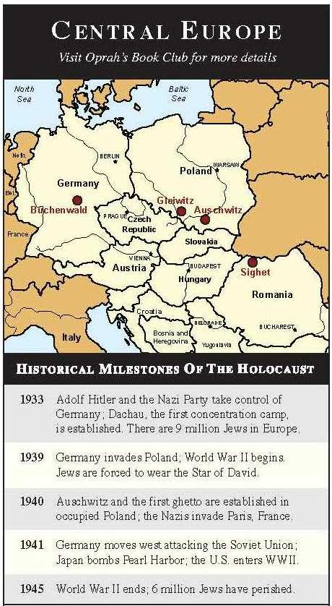
- Why did Elie Wiesel write this book?

- In what way did Hitler kill the Jews “twice”?

- How was language an obstacle for Wiesel when he started writing about his memories?

- Why did Wiesel decide to publish his book with a new translation (45 years after the publication of the original manuscript)?

- What does the phrase “bear witness” mean?

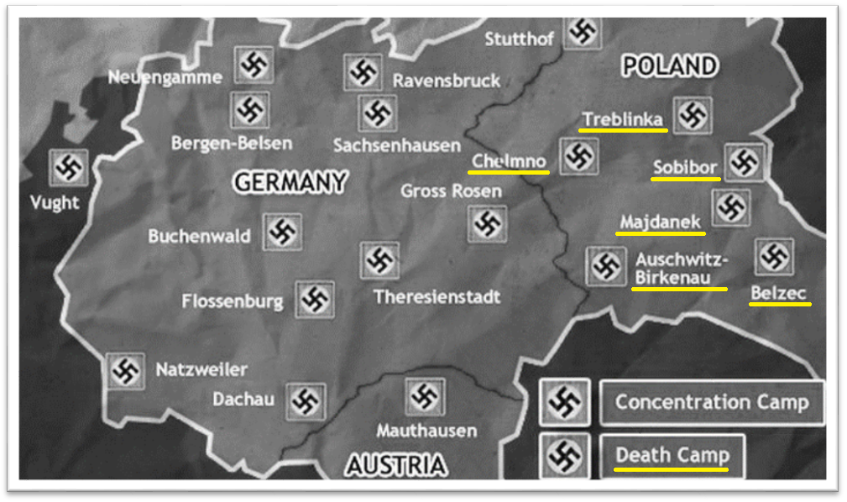
Nazi death camps - all in pre-war Poland
holocaust: a completely burned sacrifice

- Auschwitz: (largest) 1941-1945 exterminated up to 10,000 per day; 11 rail lines
liberation: January 27, 1945 – 7,000 prisoners left (most ill and dying)
  - Auschwitz I: main camp (workshops; armament industries)
  - Auschwitz II: Birkenau (extermination camp: crematoria & barracks)
  - Auschwitz III: Buna-Monowitz (slave labor camp; war industries)
- Belzec 1942
- Chelmno 1942-3
- Majdanek 1942-44 (labor and extermination)
- Sobibor 1942-43
- Treblinka 1942-43

- 11-17 million killed
  - 6 million Jews (2/3 of Europe’s Jewish population)
  - 3.3 million Soviet POWs
  - 2 million non-Jewish from Poland
  - 270,000 gypsies
  - 250,000 disabled
  - 15,000 homosexuals
  - 5,000 Jehovah’s Witnesses
  - ¼ killed were under the age of 15

A Day In Auschwitz – Kitty Hart Moxon’s Story of Survival
https://www.youtube.com/watch?v=mZYgzW2fS0o
Answer the following questions based on the video.

- What did the Gypsy woman notice when she looked at Kitty’s palm?

- What did Kitty decide to do when she realized the Gypsy woman who slept next to her had died during the night (her first day in the camp)?

- What did they do with the hair that they shaved off of the prisoners?

- What would the prisoners have done if they ever saw a blade of grass?

- Why was it best NOT to be at the beginning or the end of the food line?

- What problems did the prisoners have with going to the bathroom in the middle of the night?

- What were her duties when she worked in the lavatory?

- Why was this lavatory job a great job compared to others?

- What did they use their bowls for (2 things)?

- What were Kitty’s duties in the building known as KANADA – where the prisoners’ suitcases were dropped off)?

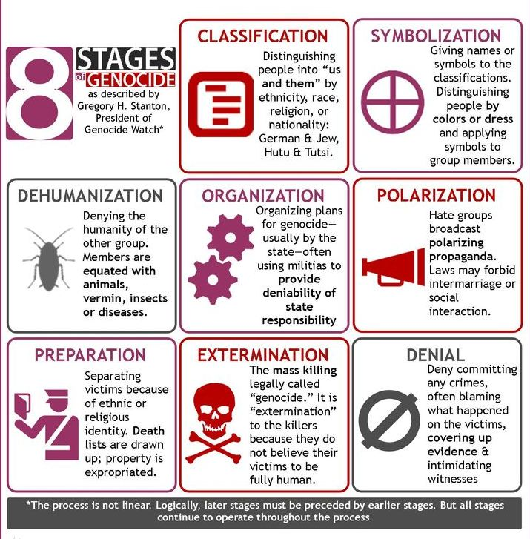

First They Came For The Jews
by Martin Niemöller
First they came for the Jews
and I did not speak out
because I was not a Jew.
Then they came for the Communists
and I did not speak out
because I was not a Communist.
Then they came for the trade unionists
and I did not speak out
because I was not a trade unionist.
Then they came for me
and there was no one left
to speak out for me.

Transit by Rita Dove
If music be the food of love, play on.
—Alice Herz-Sommer, survivor of the
Theresienstadt ghetto/concentration camp

This is the house that music built:
each note a fingertip’s purchase,
rung upon rung laddering

across the unspeakable world.
As for those other shrill facades,
rigged-for-a-day porticos

composed to soothe regiments
of eyes, guilt-reddened,
lining the parade route

(horn flash, woodwind wail) . . .
well, let them cheer.
I won’t speak judgment on

the black water passing for coffee,
white water for soup.
We supped instead each night

on Chopin—hummed our grief-
soaked lullabies to the rapture
rippling through. Let it be said

while in the midst of horror
we fed on beauty—and that,
my love, is what sustained us.

Something, For the Children of Sandy Hook
by Michael Burch
Something inescapable is lost—
lost like a pale vapor curling up into shafts of moonlight,
vanishing in a gust of wind toward an expanse of stars
immeasurable and void.
Something uncapturable is gone—
gone with the spent leaves and illuminations of autumn,
scattered into a haze with the faint rustle of parched grass
and remembrance.
Something unforgettable is past—
blown from a glimmer into nothingness, or less,
and finality has swept into a corner where it lies
in dust and cobwebs and silence.

Recipe of the Holocaust by Antonia Williams
Here is my death recipe,
made specially for the Holocaust.
The horror of Anti-Semitism
That struck Jews during the Second War.
First there is that shock of Fate
that plunged deep in their prejudiced hearts.
Next add in their swelling of fear,
as you wonder where they're taken far.
Drag them to concentration camps,
then butterflies will start to show
Spread around the rumors of others.
Where have they gone? We're not to know.
Garnish with unceasing sadness
that forever is clouded in your mind.
Those beloved friends and family.
In the end, you will be left behind.
Stand up to the horrors for a few more years.
Be prepared for gruesome pains,
because just as you're about to breathe your last
you'll suddenly see some light again.
Perhaps it's too frightening to think about this.
'It's hopeless to try! ' you yell at me.
Just don't be afraid to cry and mourn.
For remembrance is the final part of the recipe.

Analyzing poetry
poems | identify one key line or phrase from the poem  (a line that reveals the poet’s idea) | list THREE key words in the poem that reveal the poet’s idea (they can be in different lines) | explain how these lines/phrases/words create meaning for the reader | How does the poem connect to Night?
“First They Came For The Jews”
“Transit”

“Something, For the Children of Sandy Hook”

“Recipe of the Holocaust”

Random House teacher's guides http://www.randomhouse.com/highschool/guides/night.html
Holocaust, a Greek word that means “complete destruction by fire.”
Holocaust: The destruction of some 6 million Jews by the Nazis and their followers in Europe between the years 1933 and1945. Other individuals and groups were persecuted and suffered grievously during this period, but only the Jews were marked for complete and utter annihilation. The term "Holocaust" literally meaning "a completely burned sacrifice" tends to suggest a sacrificial connotation to what occurred. The word Shoah, originally a biblical term meaning widespread disaster, is the modern Hebrew equivalent.

Jewish Terminology
- Kabbalah: The Jewish mystical tradition.
- Hasidic: A branch of Orthodox Judaism that maintains a lifestyle separate from the non-Jewish world.
- Kaddish: A prayer in Aramaic praising God, commonly associated with mourning practices.
- Rabbi: A religious teacher and person authorized to make decisions on issues of Jewish law. Also performs many of the same functions as a Protestant minister.
- Rosh Hashanah: The new year for the purpose of counting years.
- Sodom: Wicked Biblical city that suffers God's wrath.
- Synagogue: The most widely accepted term for a Jewish house of worship.
- Talmud: The most significant collection of Jewish oral tradition interpreting the Torah.
- Torah: The entire body of Jewish teachings.
- Yom Kippur: A day set aside for fasting, depriving oneself of pleasures, and repenting from the sins of the previous years.
- Zohar: The primary written work in the mystical tradition of the Cabbala.
Nazi and Holocaust Terminology
- Anti-Semitism: Systematic prejudice against Jews.
- Appleplatz: center of the camp; meeting ground
- Aryan: In the Nazi ideology, the pure, superior Germanic (Nordic, Caucasian) race.
- Auschwitz (Birkenau, Buna, and Gleiwitz): Concentration camp and extermination camp in Upper Silesia, Poland. By 1942, it consisted of three sections: Auschwitz I, the main camp; Birkenau, an extermination camp; and Buna, a labor camp. Gleiwitz was a subcamp in Auschwitz.
- Beethoven, Ludwig van: German composer (1770-1827). Linked only to the Holocaust by race and the fact that Jews were forbidden to play the music of German composers.
- Blockalteste: block leader
- Buchenwald: Concentration camp in Germany, between Frankfurt and Leipzig. Although not a major extermination center, it was equipped with gas chambers and a crematorium. More than 100,000 prisoners died there.
- Concentration camp: Immediately upon their assumption of power on January 30, 1933, the Nazis established concentration camps for the imprisonment of all "enemies" of their regime: actual and potential political opponents (e.g. communists, socialists, monarchists), Jehovah's Witnesses, gypsies, homosexuals, and other "asocials." Beginning in 1938, Jews were targeted for internment solely because they were Jews. Before then, only Jews who fit one of the earlier categories were interned in camps. The first three concentration camps established were Dachau (near Munich), Buchenwald (near Weimar) and Sachsenhausen (near Berlin).
- Crematory: The place that contained the ovens, furnaces, and chimneys where Nazi victims were burned dead or alive.
- Death camp: A concentration camp, the distinct purpose of which was the extermination of its inmates. Almost all of the German death camps were located in Poland: Auschwitz-Birkenau, Belzek, Chelmo, Madjanek, Sobibor, Treblinka.
- Death's head: Nazi skull symbol worn on SS uniforms.
- Dysentery: An intestinal disorder causing blood and mucus in the stool.
- Fascist: One who supports a political movement that advocates a nationalist dictatorship, private ownership of property, but state controlled economy. Primarily, Fascism is linked to the regime of Italy's Benito Mussolini, but Naziism is an example of a Fascist government.
- Gestapo: The German internal security police--secret police. The Gestapo was organized in 1933 to protect the regime from political opposition.
- Ghetto: The ghetto was a section of a city where all Jews from the surrounding areas were forced to reside. Surrounded by barbed wire or walls, the ghettos were often sealed so that people were prevented from leaving or entering. The ghettos were characterized by overcrowding, starvation and forced labor. All were eventually destroyed as the Jews were deported to death camps.
- Gross-Rosen: A subcamp of concentration camp Sachsenhausen, which prisoners were destined for hard work in local quarry of granite. On May 1, 1941, Gross-Rosen gained the status of self-reliant concentration camp. In the course of its first two years of existence, Gross-Rosen was a small camp still set service of quarry. Murder, twelve hours of work in the quarry, starving rations of food, lack of proper medical care, incessant maltreatment and terrorization of prisoners both by SS crew and functionary prisoners caused great mortality, and Gross-Rosen was reckoned as one of the hardest concentrations camps.
- Gypsy: A nomadic race persecuted by the Nazis.
- Kapo: Prisoner in charge of a group of inmates in Nazi concentration camps.
- Kommandos: work groups
- Lageralteste: head of entire camp
- Lagerkapo: head kapo
- Mengele, Josef: (1911-1978?) SS physician at Auschwitz, notorious for pseudo-medical experiments, especially on twins and Gypsies. He "selected" new arrivals by simply pointing to the right or the left, thus separating those considered able to work from those who were not. Those too weak or too old to work were sent straight to the gas chambers, after all their possessions, including their clothes, were taken for resale in Germany. After the war, he spent some time in a British internment hospital but disappeared, went underground, escaped to Argentina, and later to Paraguay, where he became a citizen in 1959. He was hunted by Interpol, Israeli agents, and Simon Wiesenthal. In 1986, his body was found in Embu, Brazil.
- Petrol: Gasoline. Used by the Nazis to disinfect prisoners.
- Red Army: Slang term for the Russian army.
- Russian Front: The line of conflict between the German and Russian armies.
- Selection: Euphemism for the process of choosing victims for the gas chambers in the Nazi camps by separating them from those considered fit to work.
- SS: Abbreviation usually written with two lightning symbols for Schutzstaffel (Defense Protective Units). Originally organized as Hitler's personal bodyguard, the SS was transformed into a giant organization by Heinrich Himmler. Although various SS units fought on the battlefield, the organization is best known for carrying out the destruction of European Jewry.

Nobel Prize Acceptance Speech – December 10, 1986 – reading questions
speech is on pp. 117-120 in the book Night

- Explain: It happened yesterday, or eternities ago.

- Explain: If we forget, we are guilty, we are accomplices.

- Explain: Silence encourages the tormentor, never the tormented.

- Explain: Human suffering anywhere concerns men and women everywhere.

- Explain: Our lives no longer belong to us alone; they belong to all those who need us desperately.

Night quick write
You have just read the book Night, by Elie Wiesel and watched two documentaries about life in Auschwitz (One Day in Auschwitz with Kitty Moxon Hart and Elie and Oprah at Auschwitz). Thinking about both the novel and the videos … what scenes stick with you? Why?

Write an essay that presents your reaction to this topic.
- Be sure that you mention at least two specific scenes – at least one must be from the book.

- You must discuss the book. You do not have to discuss the documentaries.

- Be sure to give details (who, what, when, where, why, how, etc.)

- Be specific about your opinion/reaction. Include EACH of the following topics:
  - What’s in the text? Some options: What did the text say about this topic? What does Wiesel/Hart want you to know? What did you learn about the Holocaust?
  - What’s in your head? Some options: What effect has it had on you? What did you notice? What surprised you? What questions has this information raised for you? What else do you want to know about the Holocaust? What message do you feel this scene might convey about life and human nature? How has this information changed/challenged/confirmed how you think?
  - What did you take to heart? Some options: What did you learn about YOU? How will this information affect the way you think or behave? How did the text change you? What affect has it had on your understanding of the Holocaust? What affect has it had on your understanding of current events?

What scenes stick with you? Why? | scene one  (must be from the book) | scene two  (can be from the book or a video)
What’s in the text/video?
What’s in your head?
What did you take to heart?

